Tyler Niles
4/5/2010
ENGG 8840

Project Goals & Steps

Topic: Generating and Deciphering Stereograms

Goals
- Write a C program to Generate a Stereogram given a grayscale image.
A.) This will likely be a program using the Random-Dot approach.
B.) The Random Strip applied to create the illusion of depth will be hard-coded.
C.) One image file in, One stereogram out.
- Write a C program to Decipher stereograms given a grayscale stereogram.
A.) This will leverage the Minimal-Area Minimization (MAM) based approach as discussed in Kimmel¹.
B.) One stereogram in, One image file out.
- Learn about stereograms.
- Have fun!! ☺

Other:
- Files will be handled as Raw data.
- Images will be dealt with in Grayscale
- Deliverables will include all source code for both programs as well as sample images which have been processed.

Necessary Steps

(By 4/13)
- Write a C program to create random dot stereograms.
A.) Verify required nature of input image (3D model, or any image?).
(By 4/27)
- Write a C program to decipher 3D shape from Random Dot stereograms.
B.) Verify mathematical process of Minimal-Area Minimization.
(By 5/3)
- Write report.

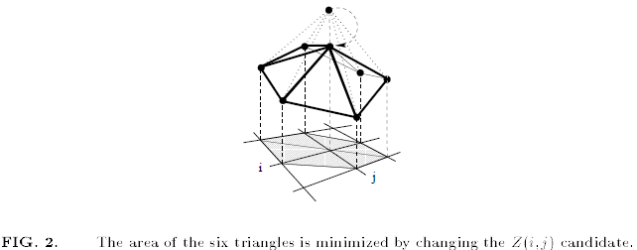

1. Kimmel, Ron. “3D Shape Reconstruction from Autostereograms and Stereo”. Technion, Haifa, Israel. 2000.

